AT3 – Project

JMC Music Player

Pre-Design Specification

Student:

Reece Pieri

Student ID:

M087496

Course:

Diploma of Software Development – Java III

Contents

UML Class Diagram 3

Server 3

Client 4

Third-Party Libraries 5

Test Data 6

Sample Unit Test 7

Source Control Repository 8

# UML Class Diagram

Server

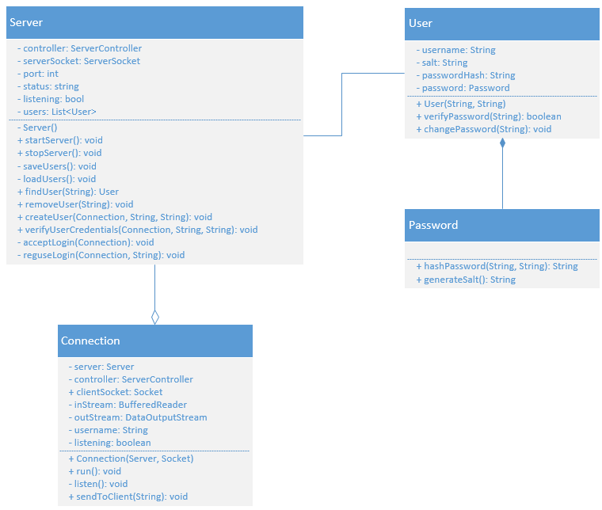

Client

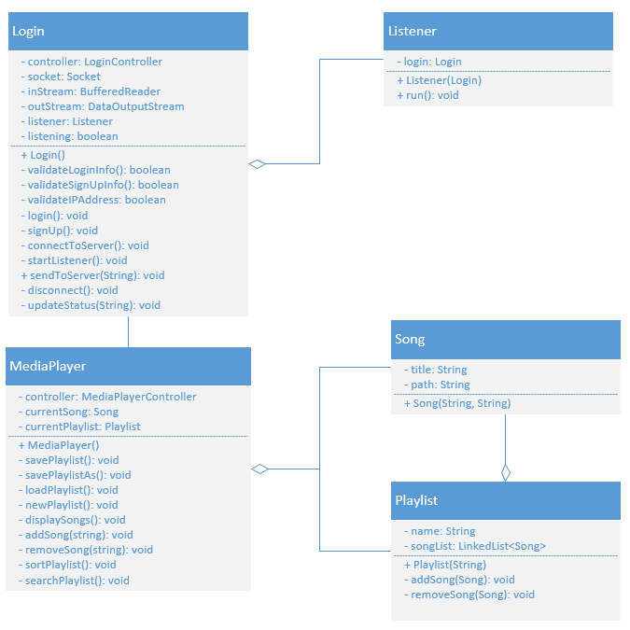

# Third-Party Libraries

|  |  |
| --- | --- |
| **Name** | **Function** |
| OpenCSV | Reads and parses .csv files. |

# Test Data

|  |  |  |  |
| --- | --- | --- | --- |
| **Test Case** | **Description** | **Expected Result** | **Actual Result** |
| Case 1 | Start server | Load user information from file and begin listening for incoming connections |  |
| Case 2 | Stop server | Save user information to file and stop listening for incoming connections |  |
| Case 3 | Remove user | Remove a registered user from server |  |
| Case 4 | Login to music player client | Login successful, close login form and open music player client |  |
| Case 5 | Create a new playlist | Successfully create a new playlist |  |
| Case 6 | Add songs to playlist | Add multiple songs to playlist via Open File dialog |  |
| Case 7 | Remove songs from playlist | Song removed from playlist |  |
| Case 8 | Clear playlist | All songs cleared from playlist |  |
| Case 9 | Load playlist | Playlist loaded from CSV file |  |
| Case 10 | Save playlist | Playlist saved to CSV file |  |
| Case 11 | Play music | Song begins playing |  |
| Case 12 | Sort playlist | Merge sort performed on playlist successfully |  |
| Case 13 | Search playlist | Specified song found in playlist |  |
| Case 14 | About | Display About message box |  |

# Sample Unit Test

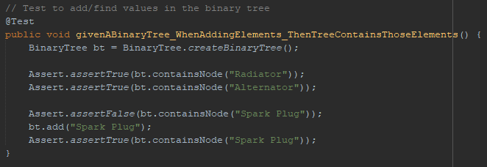

# Source Control Repository

GitHub: <https://github.com/Icemaush/JMC-Music-Player>

